First, I used this blog for help and reuse of some code:
https://medium.com/ai-society/gans-from-scratch-1-a-deep-introduction-with-code-in-pytorch-and-tensorflow-cb03cdcdba0f

both the generator and the discriminator are being modeled with neural networks, gradient-based optimization.

Generator model parameters:
3 hidden layers:
input_size : 2 – point as x,y
hidden0 – 2x256 (linear model and than leakyRelu with alpha = 0.2)
hidden1 – 256x512 (linear model and than leakyRelu with alpha = 0.2)
hidden2 – 512-1024 (linear model and than leakyRelu with alpha = 0.2)
out layer – 1024x2 (use linear model and then tanh)
output_size: 2 – point as x,y
learning rate: 0.0002
optimizer: Adam

Discriminator model parameters:
3 hidden layers:
input_size : 2 – point as x,y
hidden0 – 2x1024 (linear model and than leakyRelu with alpha = 0.2 and dropout = 0.3)
hidden1 – 1024x512 (linear model and than leakyRelu with alpha = 0.2 and dropout = 0.3)
hidden2 – 512-256 (linear model and than leakyRelu with alpha = 0.2 and dropout = 0.3)
out layer – 256x2 (use linear model and then sigmoid)
output_size: 1 ( number between 0 to 1, when x<0.5 is fake, x>0.5 is real)
learning rate: 0.0002
optimizer: Adam

for running this code – run ass3.py -[model]

if you want to run for the models use this lines:
ass3.py -line
ass3.py -par
ass3.py -spiral

each run of this code will save the final 1000 points of trained generator, here is my outputs:
(line and par models run with 500 iterations and batch of 5, and the spiral runs with 5 batch and 7000 iterations)
those changes is because the line and par was pretty easy to generate (and converge), but the spiral distribution was really hard..

LINE:
real: fake:
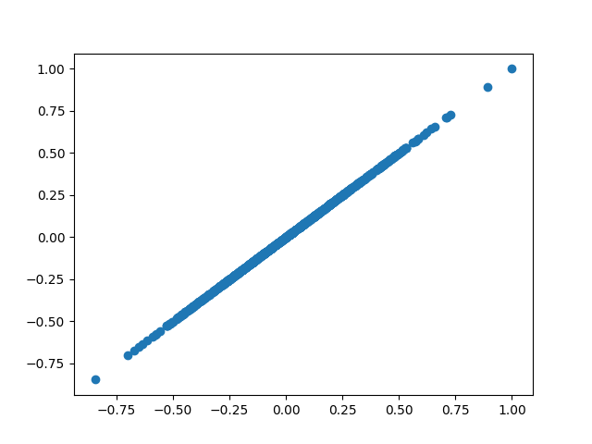
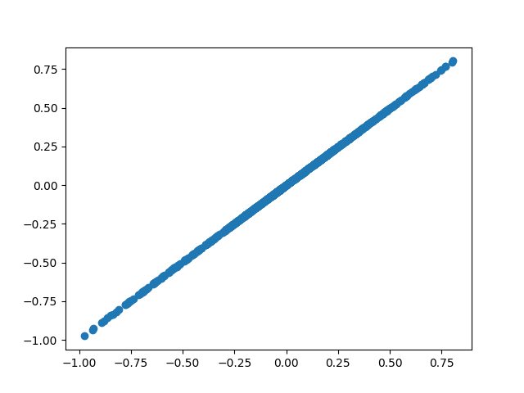

PAR:
real: fake:
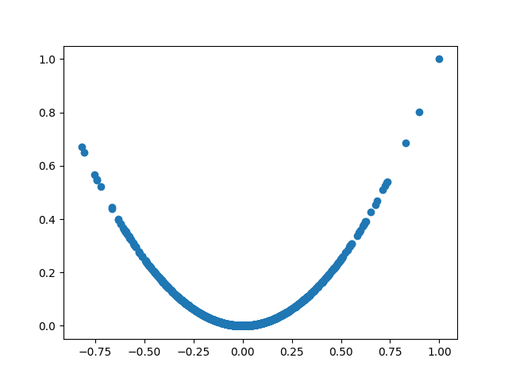
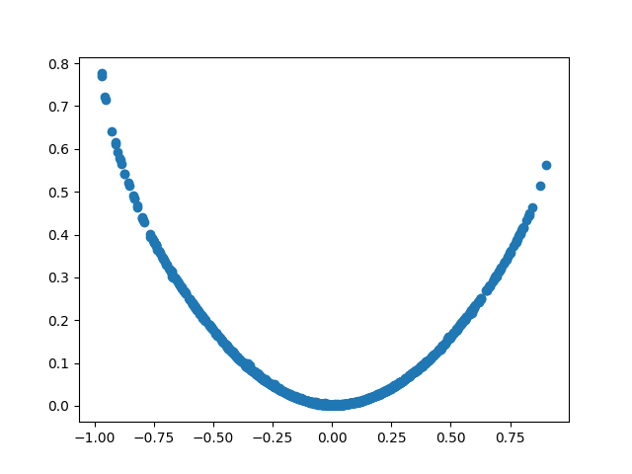

SPIRAL:
real: fake:
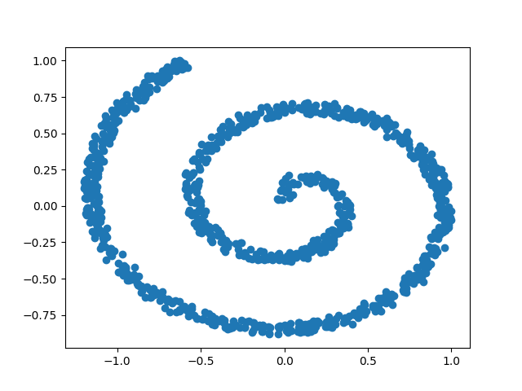
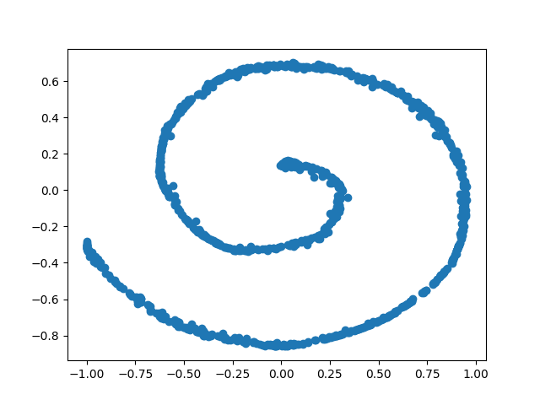

I guess I might use more iterations… but it’s still very close!:)

